



eIDEAS

**User Guide to:**

**Manage Account & Navigating eIDEAS**

**Created by !cool**

**Version 1: November 2018**

**Table of Contents**

**1. Manage Account....................……………….……………………………………………………………......1**

**2. Home Page..………..……….……………………....................................……………………………………4**

**List of Figures**

Figure 1-1. Home Page: Showing Button for Manage Account.…………………………………......1

Figure 1-2. Manage Account Page......………......….................................……………………………………1

Figure 1-3. Manage Account: Change Password..................................................………………………2

Figure 1-4. Manage Account: Personal Data............................................................................…………3

Figure 1-5. Manage Account: Delete Account.........................................................................…………3

Figure 2-1. Home Page: Navigation.……….…………...............................................………………………4

**1. Manage Account**

1. To manage your account click on “Hello *YourName*!” at the top right corner of the screen shown in Figure 1-1. The Manage Account page is shown in Figure 1-2.

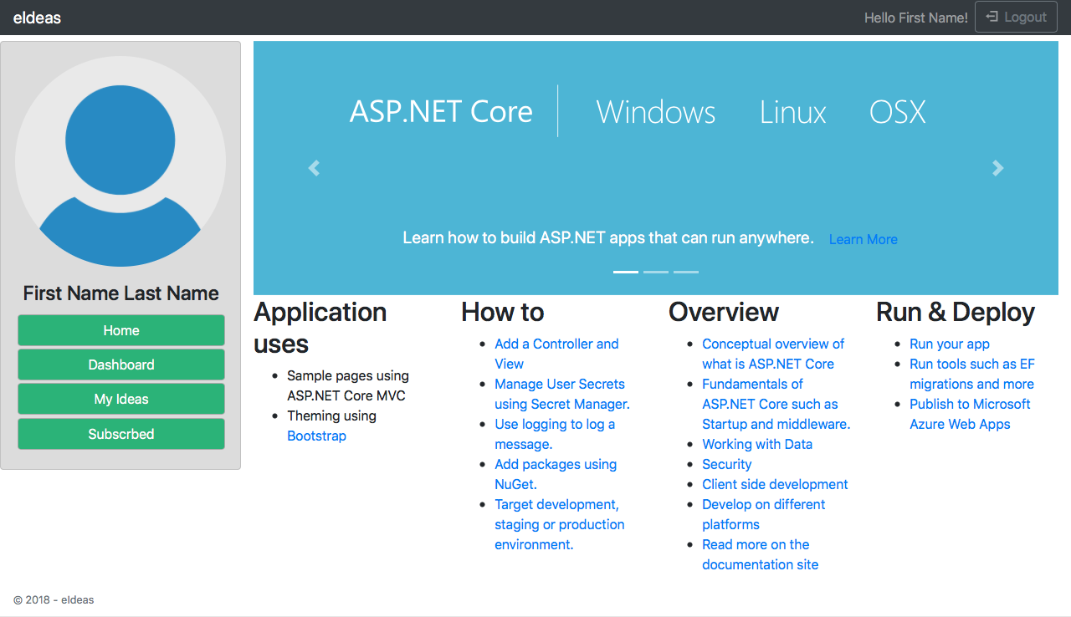

***Figure 1-1. Home Page: Showing Button for Manage Account***

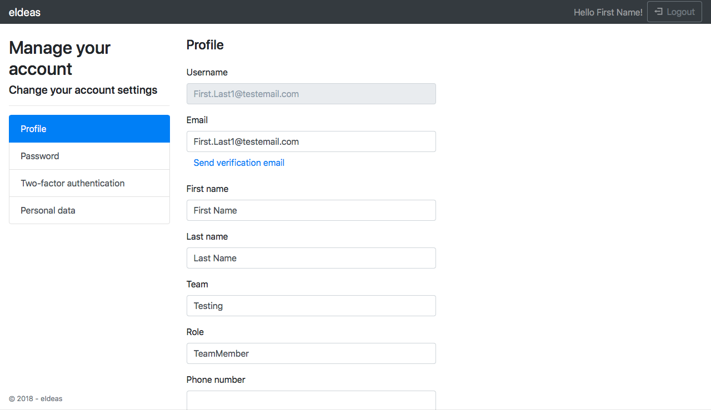

***Figure 1-2. Manage Account Page***

1. From here you can do the following:
   1. Update your Email & Verify it;
   2. Update your First & Last Name;
   3. Update your Team & Role;
   4. Update your Phone Number;
   5. Update your Password;
   6. Two Factor Authenticate your profile; and
   7. Download or Delete your profile
2. To update your information, press “save” at the bottom of the page.
3. If you wish to change your password, click on the “Password” button on the left hand side shown in Figure 1-3. You will need your current password. A Password that consists of:
   1. At least 6 characters;
   2. At least 1 non- alphanumeric. For example “!”;
   3. At least 1 uppercase letter (‘A’-‘Z’); and
   4. At least 1 digit (‘0’-‘9’)

You will need to retype this password into Confirm Password.

**NOTE:** If there are any issues with any field above, you will not have your password changed and an error message will be shown with the problem. An example of an error is shown in Figure 1-3

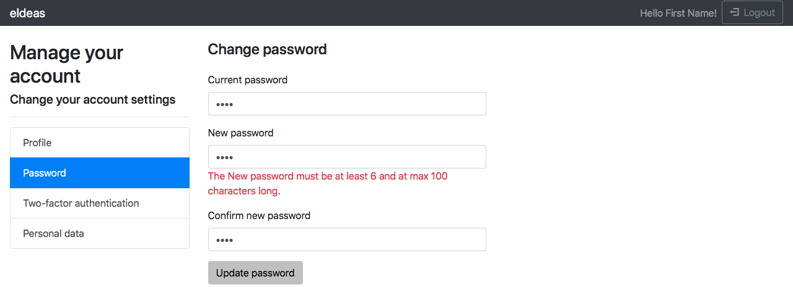

***Figure 1-3. Manage Account: Change Password***

1. If you wish to delete your account, click on the “Personal Data” button on the left hand side shown in Figure 1-4. After clicking “Delete”, you will need to enter your current password. Once you are sure you want to delete your account press “Delete Data and Close My Account”, shown in Figure 1-5.

**IMPORTANT:** ONCE YOUR ACCOUNT IS DELETED AND CLOSED, YOU CANNOT REOPEN IT. ALL YOUR ACCOUNT DATA WILL BE LOST AND CANNOT BE RECOVERED.

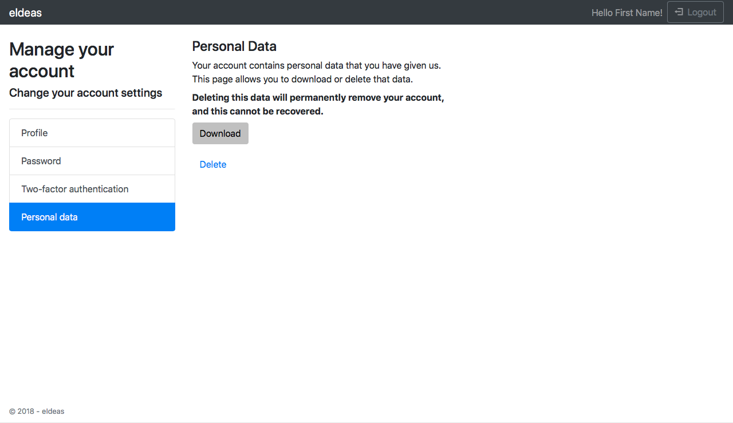

***Figure 1-4. Manage Account: Personal Data***

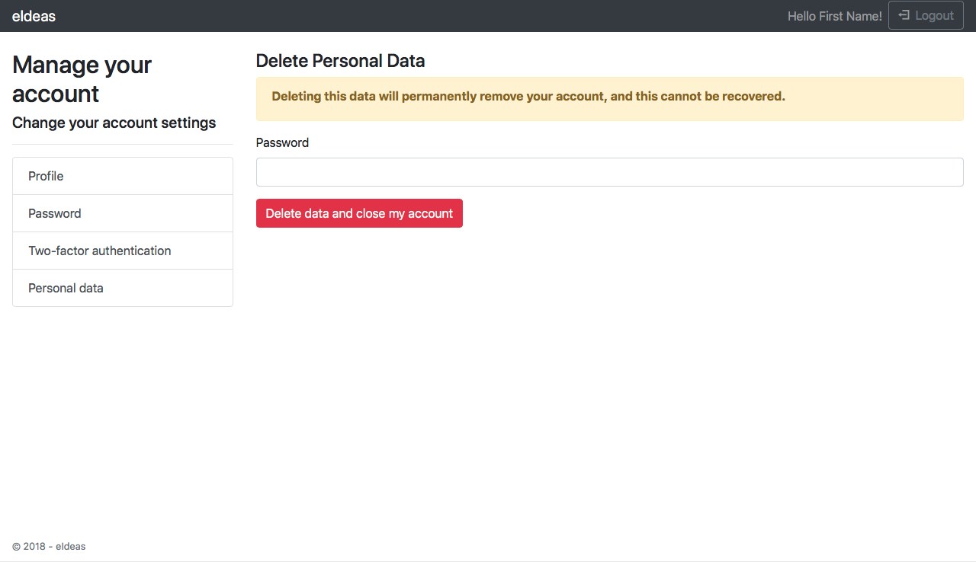

***Figure 1-5. Manage Account: Delete Account***

**2. Home, Dashboard, My Ideas, & Subscribed**

1. To get to the Home Page, press “eIdeas” on the top left of the screen, or (if visible) press the “Home” button on the left hand side.
2. To get to the Dashboard, press “Dashboard”.
3. To get to My Ideas, press “My Ideas”.
4. To get to Subscribed Ideas, press “Subscribed”. All buttons are shown below in Figure 2-1.



***Figure 2-1. Home Page: Navigation***